**CONCLUSIONS AND RECOMMENDATIONS**

After performing the requested executions, we had to make an analysis of the results.

One thing that should be taken into account by its great importance, is that at the time of the executions a problem where the server rejects Pivotal Tracker showing many requests had the following error:

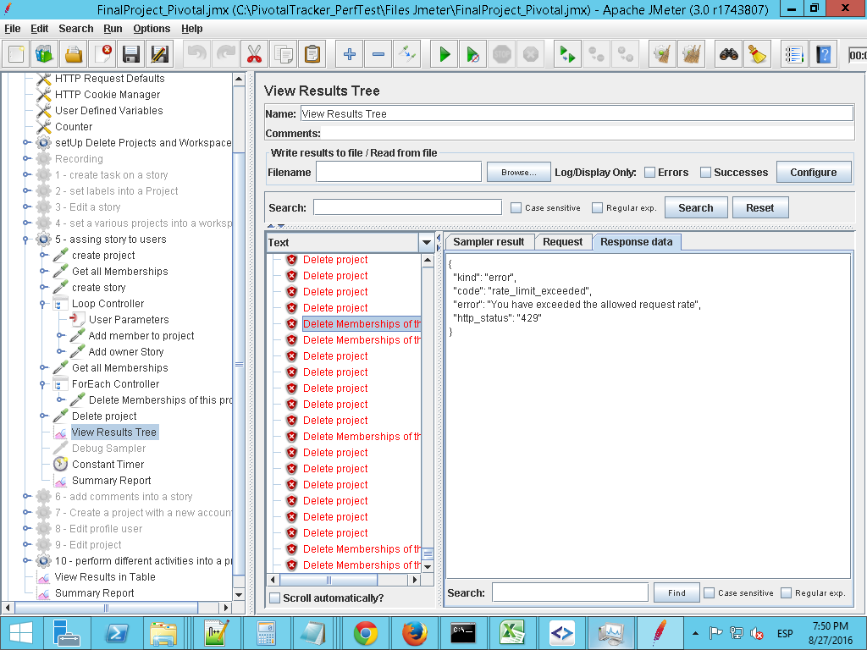

This is due to the large number of sent and applied in a short time requests.

**ANALYSIS OF RESULTS**

**Conclusion:** The graphic shows expected results, as the number of requests is rising according to increase of users

**Recommendations:** Non

**Conclusion:** Due to requests that are not able to realize this chart has changed.

The second may be necessary to repeat execution.

**Recommendations:** It is recommended to repeat executions with longer waiting times for other results

**Conclusion:** By the graph we can see that the number of bytes received is increasing according to the number of users. It is an expected result.

**Recommendations:** Perform load larger users to better appreciate the increase of bytes received.

**Conclusion**: We can see a lot of errors in executions carried out.

**Recommendations**: It is recommended executions where the error rate is minimum to get real results.